Types of Autonomous Systems
# Source: AI Source: Provided by: [Data Path: Persons Table -> ID Column: 1, Name_En Column: Motasem Essam] -> From: [ChatGPT] on [1/16/2026]
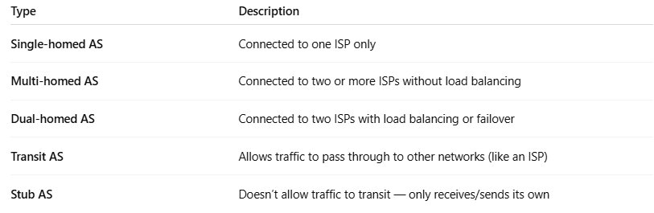
Type | Description
Single-homed AS | Connected to one ISP only
Multi-homed AS | Connected to two or more ISPs without load balancing
Dual-homed AS | Connected to two ISPs with load balancing or failover
Transit AS | Allows traffic to pass through to other networks (like an ISP)
Stub AS | Doesn’t allow traffic to transit — only receives/sends its own

